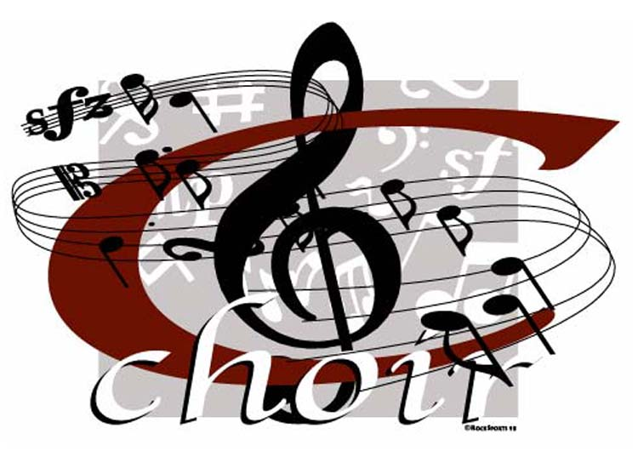

ALGONQUIN MIDDLE SCHOOL
Choir Handbook

2015-2016
Ms. Colleen Sinclair, Director of Choirs
847.532.7207

Welcome!

Dear AMS Choir Students and Parents,

Welcome to the choir program here at Algonquin Middle School! I am looking forward to working with everyone involved in the choir department, whether new or returning! As the Director of Choirs here at AMS, I am excited to give students the opportunity to grow as musicians, singers, listeners, life-long learners and as people.

Attached you will find information about class requirements, goals, expectations, concert dates, etc. Please read through the information and return the attached Vocal Music Agreement by Friday, August 28th.

Please feel free to contact me if you have any questions. Since phone calls are sent straight to voice mail during the school day, the best way to contact me for a fast response is through email. I look forward to a great year of music-making!

Sincerely,
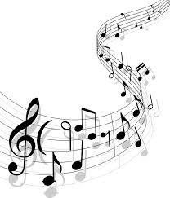
Colleen Sinclair
Director of Choirs
Algonquin Middle School
Colleen.Sinclair@d300.org
amschoirpage.weebly.com
847-532-7100 ext: 7201

Ms. Sinclair’s Choral Philosophy
As a life-long student of music, I am able to look back at my experiences in the music classroom and see how it has shaped me into the musician and the person I am today. I cannot wait to share concepts of music theory in my classroom and develop the ear to identify melodies and intervals, but more than that I hope to teach life-long skills that you can apply in all aspects of life. Being part of a music ensemble develops personal accountability, confidence, respect for other cultures and beliefs, and a team mentality. In addition to teaching musical concepts, I strive to foster all of these skills in the choir classroom; ultimately experiencing the joy performing music can bring to the audience and the performer.

In-Class Goals
- Students will become literate and independent vocal musicians.
- Students will receive an introduction to the physiology of the human voice and the technique for singing properly.
- Students will perform a varied repertoire of music.
- Students will receive a sequenced curriculum of music theory, listening skills, and musical vocabulary.
- Students will actively engage in musical problem solving and artistic, creative problem decision making.
- Students will sing in settings of large ensemble, small ensemble, and solo.
- Students will participate as musical critics and active listeners through writing projects and classroom discussion.

Grading Procedures:
Quarter grades will be based on the following:
40% | Formative (Vocal Assessments & Quizzes )
25% | Concert and Rehearsal Attendance & Preparedness
15% | Music Theory Summative
15% | Practice Assignments (bell ringers, theory assignments, homework)
5% | Academic Behavior

Classroom Procedures:
Concert and Rehearsal Attendance
Regular and punctual attendance is essential to our success. A calendar of events is included at the end of this handbook. Please use this information when planning work schedules, family vacations, and other outside commitments. Attendance at concerts is mandatory. Absences from performances should only be for illness and family emergencies. If there is an absence for the aforementioned reasons, a makeup assignment will be provided.

Music Theory & Vocal Assessments
Students will be given a formal assessments in the form of a quiz or test to evaluative their knowledge of theory concepts covered in class. Occasionally, students will be voice tested using the material we have been working on in class.

Bell Ringers
Students are expected to keep a bell ringer notebook with them in class. There will be a question posted at the beginning of class. The first few minutes of class should be spent answering this bell ringer. These will be collected bi-weekly for content.

Course Registration, Dropping, and Splitting courses
If students are registered in chorus and a different ensemble (band or orchestra) they will split the time between the two ensembles; the schedule will rotate. Signs will be posted outside of the classrooms reminding students which day it is.

STEP 1: A student may drop band/orchestra/chorus within the first two weeks of the first semester. Simply complete the add/drop form and submit to the music teacher. A schedule change will occur within a few days of submission.
STEP 2: If a student wants to drop or split band/orchestra/chorus after this time, the student along with his/her parents must meet with the music teacher to discuss the situation.
STEP 3: If, after meeting, it is in the best interest of the student, the student will be allowed to drop.

THE LAST DAY TO DROP A MUSIC COURSE IS FRIDAY, AUGUST 28th

Co-Curricular Activities
Solo and Ensemble
In the spring (April 11th), District 300 offers the chance for students to participate in an in-district Solo and Ensemble contest. At this event, students participate in solo or small ensemble performances and are given evaluations and comments by a judge. This is a great chance for students to sing different repertoire and demonstrate their independent musicianship.

D300 Choral Festival
The D300 Choral Fest is a great place for students to sing with a larger group of students in the district under a professional conductor. A select representation of students will be chosen from the AMS choirs to participate in this event. It takes place on October 20th and includes a rehearsal on October 19th in the evening and during the day of the concert. Students will be excused from class on that day.

IMEA
Auditions for the junior Illinois Music Educators Association festival are held on October 4th at Yorkville Middle School. The event itself will take place November 1st. This is a great opportunity for students to sing for an esteemed guest conductor accompanied with the best singers and musicians in our region. Participation is optional, but strongly encouraged.

AMS Musical
The Algonquin Middle School Musical allows all AMS students to participate in the music program. Acting, singing, and dancing roles, as well as technical assistance, are needed. The musical is open to all students; however enrollment in choir is strongly encouraged to develop the musicianship needed to excel in this opportunity. Auditions will be held in early December, before winter break.

‘Stay Tuned’ A Cappella Choir
AMS has an a cappella choir that rehearses twice a week after school. This will be an audition only ensemble of less than 20 male and female singers. This ensemble will perform pop and jazz pieces at various concerts and events throughout the school year. Auditions will be held during the first few weeks of school.

Other Information

Performance Code of Conduct
As a member of AMS Choirs, you serve as ambassadors of Algonquin Middle School. Any conduct which is not exemplary or which reflects poorly on Algonquin Middle School will be dealt with according to the infraction and could result in dismissal from the group. We are one of the most visible organizations on this campus, and it is expected that you will always behave like mature young adults. Let’s make AMS proud!

Uniform Policies
Each student participating in choir at Algonquin Middle School is expected to adhere strictly to our uniform code at the possible expense of concert grade points. In an attempt to further enhance our professional stage appearance, the dress code for concerts will be as follows:

Men: Black dress shirt, black dress slacks, black leather belt, black dress socks, black dress shoes. Optional dark colored tie.
Women: Short or long sleeved nice, black shirt and black pants or skirt (hems should fall at or below the knees). A solid black dress may also be worn if it is school appropriate AND the hem falls at or below the knee. Black close-toed dress shoes (no flip flops or gym shoes).

Music Boosters and Parental Involvement
Parental involvement is crucial to the success of AMS Choirs. We hope that you will be able to help in any way possible. The best way to get involved is to come to our monthly booster club meetings. The first meeting is September 3rd at 7:00pm in the band room. Should you have any questions regarding your student or choir at AMS, please do not hesitate to contact me. Email is the best way to reach me for the fastest response.

What  2015 – 2016 AMS Music Calendar | When | Where
Quarter 1
Orchestra Festival Rehearsal | October 1st, 6:30 pm | DCHS
AMS Stars Benefit Concert | October 2nd, 6:30 pm | AMS Gym
IMEA Auditions | October 3rd, 8:00 am | Yorkville Middle School
Orchestra Festival Rehearsal | October 8th, 9:30 am  (Field Trip) | DCHS
Orchestra Festival Rehearsal | October 15th, 9:30 am  (Field Trip) | DCHS
Orchestra Festival Concert | October 15th, 7:00 pm | DCHS
Quarter 2
Choral Festival Rehearsal | October 25th, 5:30 pm | HHS
Choral Festival Rehearsal | October 26th, 9:00 am  (Field Trip) | HHS
D300 Choral Festival Concert | October 26th, 7:00 pm | HHS
IMEA Jazz Festival | October 31st, 8:00 am | Scullen Middle School
AMS Choir Concert | November 10th, 7:00 pm | AMS Gym
AMS Band & Jazz Concert | November 17th, 7:00 pm | AMS Gym
AMS Orchestra Concert | November 19th, 7:00 pm | AMS Gym
ILMEA Festival | November 21st | Plano High School
Honors Band Rehearsal | November 30th, 6:30 pm | Westfield
Quarter 3
Honors Band Rehearsal | January 7th, 6:30 pm | CMS
Honors Band Rehearsal | January 12th  (Field Trip) | HMS
Honors Band Concert | January 12th, 7:00 pm | HMS
AMS Orchestra Concert | February 18th, 7:00 pm | AMS Gym
AMS Choir Concert | February 23rd, 7:00 pm | AMS Gym
AMS Band & Jazz Concert | February 25th, 7:00 pm | AMS Gym
Foundry Jazz Night | March 8th | TBD
Quarter 4
AMS Musical | March 17th – 19th | AMS Gym
Solo & Ensemble Contest | April 9th, 8:00 am | DCHS
DCHS Musical | April 13th, 9:00 am  (Field Trip) | DCHS
8th Grade Finale Concert | May 10th, 7:00 pm | AMS Gym
6th Grade Finale Concert | May 17th, 6:30 pm | AMS Gym
7th Grade Finale Concert | May 17th, 7:30 pm | AMS Gym

