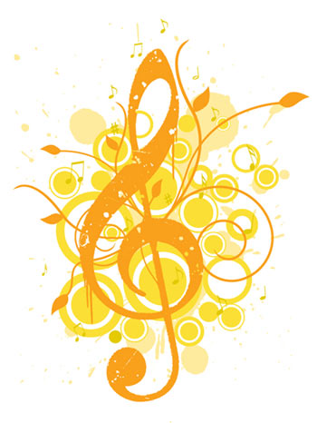
Algonquin Middle School
Eighth Grade Choir
Course Syllabus
2015-2016 School Year

Instructor: Contact Information
Ms. Colleen Sinclair Colleen.Sinclair@d300.org
Choir Director (847)532-7207
Room: 106A AMSchoirpage.weekbly.com

Course Description:
This course is designed to help students continue to develop an understanding of vocal technique in preparation for moving on to the high school level. We will focus on proper vocal production, blend, and the study of musical concepts such as composition and conducting.
Materials:
In this class you must bring the following materials every day in order to receive full credit for attending class:
It is recommended that you also bring your
assignment notebook
- Pencil
- Notebook
- Music Folder (provided by Ms. Sinclair)
- Positive Attitude
Classroom Expectations:
I expect students in this course to:
- Be in their seats before the bell (with music and pencil in hand)
- Actively participate every day
- Come to class with an open mind and positive attitude
- Attend all concerts; concerts are 100% mandatory

Classroom Rules:
My rules for this class are as simple as my expectations:
- BE ON TIME – It is disrespectful to your classmates and your teacher to show up late to class, rehearsal, or a concert. All of our time is important.
- Be Respectful – Of yourselves, your classmates, your teacher, and the music. By this point in your education you should know what appropriate classroom behavior is; turning in homework on time, do not talk when I am teaching (unless you are participating), understand that all of your classmates learn at a different pace, etc.
- No Cheating –If you are struggling with a topic, come and see me!
- No gum – There is a trash can by the door, use it please.
- All students must also follow rule listed in the Student Handbook.
Daily Procedures:
The class schedule is designed to fit short music theory lessons, warm-ups, and rehearsal time all into one period. In order to make the most of our time in class together I expect you to follow these procedures:
- Start of Class – Please check the slots by the door to pick up any new music or worksheets for the day. Then, you will take your seat and begin to answer the bell ringer in your notebook. As you leave class you will drop assignments in the ‘drop-off’ slot.
- Seating Chart –I will be voice testing you so that you will be put in one of the following voice parts: Soprano, Alto, or Baritone. Based on this assessment, you will get your assigned seat.
- Leaving Class – Please try to use the bathroom before coming to class. Should the need arise, you will need to sign out before leaving class.
- Late/Make-Up Work – If you must miss a day of class, you are expected to come to me and ask what you missed. If you miss any homework assignments, you will receive one extra day to complete it for full credit.

Grading Procedures:
Quarter grades will be based on the following:
40% | Formative (Vocal Assessments & Quizzes )
25% | Concert and Rehearsal Attendance & Preparedness
15% | Music Theory Summative
15% | Practice Assignments (bell ringers, theory assignments, homework)
5% | Academic Behavior

Uniform Policies
Each student participating in choir at Algonquin Middle School is expected to adhere strictly to our uniform code at the possible expense of concert grade points. The dress code for concerts will be as follows:
Men: Black dress shirt, black dress slacks, black leather belt, black dress socks, black dress shoes. Optional dark colored tie.
Women: Short or long sleeved nice, black shirt and black pants or skirt (hems should fall at or below the knees). A solid black dress may also be worn if it is school appropriate AND the hem falls at or below the knee. Black close-toed dress shoes (no flip flops or gym shoes).
Before each concert, we will decide on an ‘accent color’ to add to the uniform
Co-Curricular Opportunities
- AMS Stars Benefit Concert (Auditions the first week of September)
- IMEA Festival (7th & 8th Grade Only)
- District 300 Choral Festival (8th Grade Only)
- A Cappella Ensemble (Auditions TBD)
- AMS Musical, March 17th - 19th (Auditions TBD)

2015 – 2016 AMS Music Calendar
Below you will find the schedule of choir related events.
What? | When? | Where?
AMS Stars Benefit Concert | October 2nd, 6:30 PM | AMS Gym
IMEA Auditions | October 3rd, 8:00 AM | Yorkville Middle School
Orchestra Festival Concert | October 15th, 7:00 PM | DCHS
Choral Festival Rehearsal | October 25th, 5:30 PM | HHS
Choral Festival Rehearsal (Field Trip) | October 26th, 9:00 AM | HHS
D300 Choral Festival Concert | October 26th, 7:00 PM | HHS
AMS Choir Concert | November 10th, 7:00 PM | AMS Gym
AMS Band & Jazz Concert | November 17th, 7:00 PM | AMS Gym
AMS Orchestra Concert | November 19th, 7:00 PM | AMS Gym
ILMEA Festival | November 21st | Plano High School
Honors Band Concert | January 12th, 7:00 PM | HMS
AMS Orchestra Concert | February 18th, 7:00 PM | AMS Gym
AMS Choir Concert | February 23rd, 7:00 PM | AMS Gym
AMS Band & Jazz Concert | February 25th, 7:00 PM | AMS Gym
AMS Musical | March 17th – 19th | AMS Gym
Solo & Ensemble Contest | April 9th, 8:00 AM | DCHS
DCHS Musical (Field Trip) | April 13th, 9:00 AM | DCHS
8th Grade Finale Concert | May 10th, 7:00 PM | AMS Gym
6th Grade Finale Concert | May 17th, 6:30 PM | AMS Gym
7th Grade Finale Concert | May 17th, 7:30 PM | AMS Gym
Concerts are in BOLD and are mandatory!
Concert and Rehearsal Attendance
Regular and punctual attendance is essential to our success. Please use this information when planning work schedules, family vacations, and other outside commitments. Attendance at concerts is mandatory. Absences from performances should only be for illness and family emergencies. If there is an absence for the aforementioned reasons, a makeup assignment will be provided.
Choir Student and Parent Contract
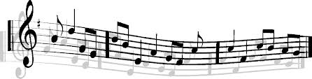
Please fill out and return this form to Ms. Sinclair no later than Friday, August 28th, 2015.

Choir Consent Form
I have read through the attached letter and I understand and agree to all my responsibilities and commitments within this packet as a member of the Algonquin Middle School Music Department. I have marked all the concert dates on my calendar at home and I understand the consequences of not attending the scheduled performances.

Student’s Name_________________________________________ Grade _______
Student Signature _______________________________________ Date________
Parent Signature_________________________________________ Date________

AMS Parent Booster and Volunteer Contact Form
There will be some regular opportunities to volunteer and be involved as the year progresses. If you would like to receive e-mails regarding volunteer opportunities and monthly Booster meetings, please include your information below and sign the attached form for official district volunteer approval.

Parent’s Name(s):_______________________ Phone Number: _______________
E-mail:_____________________________________________________________
I am interested in attending the Music Boosters club meetings: ______
I am interested in helping with concession sales at concerts: ______

